INTRODUCTION TO MATLAB NEURAL NETWORK TOOLBOX
Budi Santosa, Fall 2002

FEEDFORWARD NEURAL NETWORK
To create a feedforward backpropagation network we can use NEWFF

Syntax

net = newff(PR,[S1 S2...SNl],{TF1 TF2...TFNl},BTF,BLF,PF)
Description

NEWFF(PR,[S1 S2...SNl],{TF1 TF2...TFNl},BTF,BLF,PF) takes,
PR - Rx2 matrix of min and max values for R input elements.
Si - Size of ith layer, for Nl layers.
TFi - Transfer function of ith layer, default = 'tansig'.
BTF - Backprop network training function, default = 'trainlm'.
BLF - Backprop weight/bias learning function, default = 'learngdm'.
PF - Performance function, default = 'mse'.
and returns an N layer feed-forward backprop network.

Consider this set of data:
p=[-1 -1 2 2;0 5 0 5]
t =[-1 -1 1 1]
where p is input vector and t is target.

Suppose we want to create feed forward neural net with one hidden layer, 3 nodes in hidden layer, with tangent sigmoid as transfer function in hidden layer and linear function for output layer, and with gradient descent with momentum backpropagation training function, just simply use the following commands:

» net=newff([-1 2;0 5],[3 1],{'tansig' 'purelin'},’traingdm’);

Note that the first input [-1 2;0 5] is the minimum and maximum values of vector p. We might use minmax(p) , especially for large data set, then the command becomes:

»net=newff(minmax(p),[3 1],{'tansig' 'purelin'},’traingdm’);

We then want to train the network net with the following commands and parameter values (or we can write these set of command as M-file):

» net.trainParam.epochs=30;%(number of epochs)
» net.trainParam.lr=0.3;%(learning rate)
» net.trainParam.mc=0.6;%(momentum)
» net=train (net,p,t);

TRAINLM, Epoch 0/30, MSE 1.13535/0, Gradient 5.64818/1e-010
TRAINLM, Epoch 6/30, MSE 2.21698e-025/0, Gradient 4.27745e-012/1e-010
TRAINLM, Minimum gradient reached, performance goal was not met.

The following is plot of training error vs epochs resulted after we run the above command:

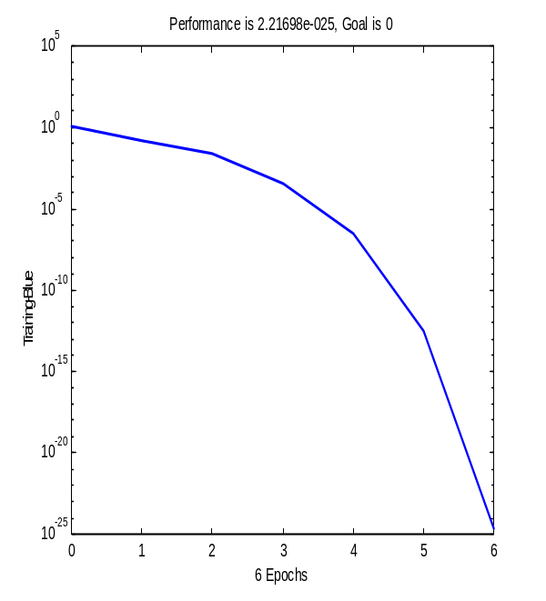
To simulate the network use the following command:

» y=sim(net,p);

Then see the result:
» [t;y]

ans =

-1.0000 -1.0000 1.0000 1.0000
-1.0000 -1.0000 1.0000 1.0000

Notice that t is actual target and y is predicted value.

Pre-processing data

Some transfer functions need that the inputs and targets are scaled so that they fall within a specified range. In order to meet this requirement we need to pre-process the data.

PRESTD : preprocesses the data so that the mean is 0 and the standard deviation is 1.
Syntax: [pn,meanp,stdp,tn,meant,stdt] = prestd(p,t)

Description

PRESTD preprocesses the network training set by normalizing the inputs (p) and targets (t) so that they have means of zero and standard deviations of 1.

PREMNMX: preprocesses data so that the minimum is -1 and the maximum is 1.

Syntax: [pn,minp,maxp,tn,mint,maxt] = premnmx(p,t)

Description
PREMNMX preprocesses the network training set by normalizing the inputs and targets so that they fall in the interval [-1,1]. Post-processing Data

If we pre-process the data before experiments, then after the simulation in order to see the output, we need to convert back to the original scale. The corresponding post-processing subroutine for prestd is poststd, and for premnmx is postmnmx.

Now, consider the following real time-series data. We can save this data as text file in MS-excel (i.e data.txt).

107.1 | 113.5 | 112.7
113.5 | 112.7 | 114.7
112.7 | 114.7 | 123.4
114.7 | 123.4 | 123.6
123.4 | 123.6 | 116.3
123.6 | 116.3 | 118.5
116.3 | 118.5 | 119.8
118.5 | 119.8 | 120.3
119.8 | 120.3 | 127.4
120.3 | 127.4 | 125.1
127.4 | 125.1 | 127.6
125.1 | 127.6 | 129
127.6 | 129 | 124.6
129 | 124.6 | 134.1
124.6 | 134.1 | 146.5
134.1 | 146.5 | 171.2
146.5 | 171.2 | 178.6
171.2 | 178.6 | 172.2
178.6 | 172.2 | 171.5
172.2 | 171.5 | 163.6

Now we would like to work on the above real data set. We have a 20 by 3 matrix. Split the matrix into two new data sets, first 12 data point as training set and the rest as a testing set. The following commands are to load the data and specify our training and testing data:

» load data.txt;
» P=data(1:12,1:2);
» T=data(1:12,3);
» a=data(13:20,1:2);
» s=data(13:20,3);

Subroutine premnmx is used to preprocess the data such that the converted data fall in range [-1,1]. Note that we need to convert our data into row vectors to be able to apply premnmx..

» [pn,minp,maxp,tn,mint,maxt]=premnmx(P',T');
» [an,mina,maxa,sn,mins,maxs]=premnmx(a',s');

We would like to create two layers neural net with 5 nodes in hidden layer.

» net=newff(minmax(pn),[5 1],{'tansig','tansig'},'traingdm')

Specify these parameters:

» net.trainParam.epochs=3000;
» net.trainParam.lr=0.3;
» net.trainParam.mc=0.6;
» net=train (net,pn,tn);

After training the network we can simulate our testing data:
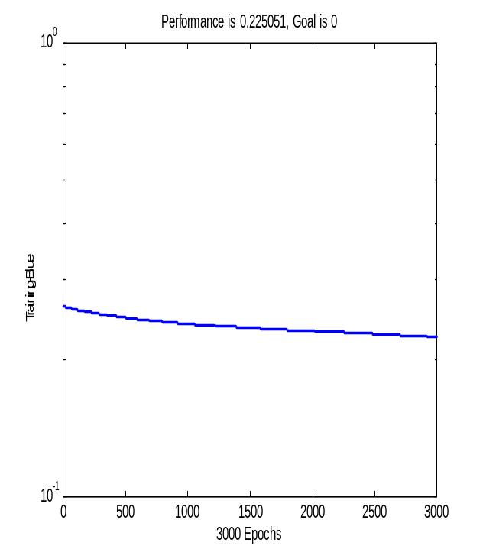
» y=sim(net,an)

y =

Columns 1 through 7

-0.4697 -0.4748 -0.4500 -0.3973 0.5257 0.6015 0.5142
Column 8

0.5280

To convert y back to the original scale use the following command:

» t=postmnmx(y’,mins,maxs);
See the results:

» [t s]

ans =

138.9175 124.6000

138.7803 134.1000

139.4506 146.5000

140.8737 171.2000

165.7935 178.6000

167.8394 172.2000

171.5000

163.6000

» plot(t,'r')
» hold
Current plot held
» plot(s)
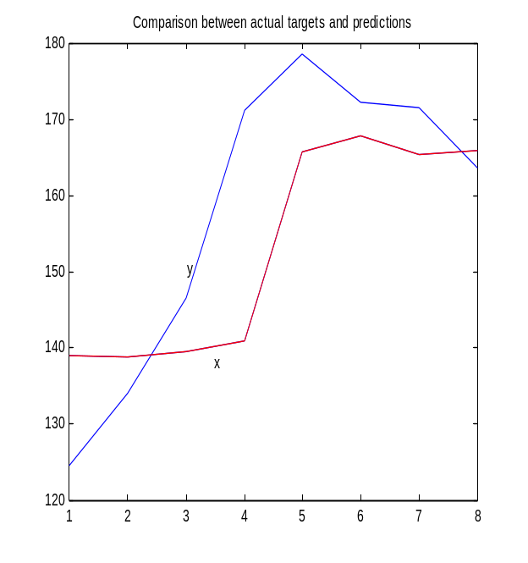
» title('Comparison between actual targets and predictions')

To calculate mse between actual and predicted values use the following commands:

» d=[t-s].^2;
» mse=mean(d)

mse =

177.5730
To judge our network performance we can also use regression analysis. After post-processing the predicted values, we can apply the following command:

t» [m,b,r]=postreg(t',s’)
m =
0.5368
b =
68.1723
r =
0.7539
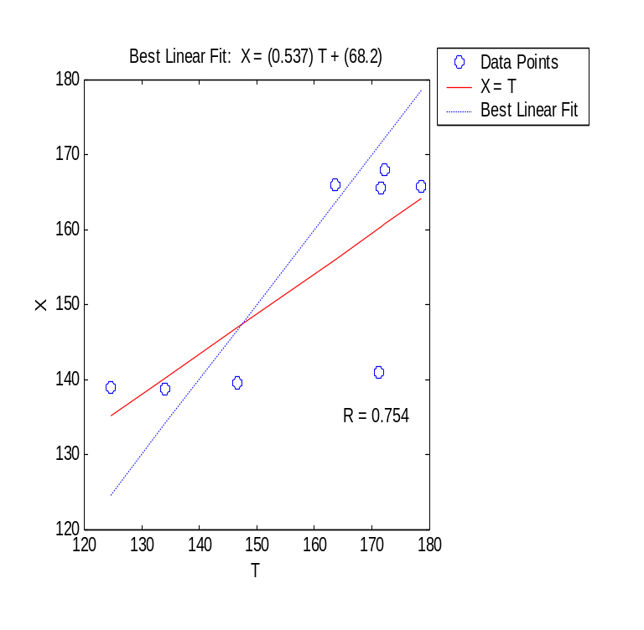

RADIAL BASIS NETWORK

NEWRB Design a radial basis network.

Synopsis

net = newrb

[net,tr] = newrb(P,T,GOAL,SPREAD,MN,DF)

Description

Radial basis networks can be used to approximate functions. NEWRB adds neurons to the hidden layer of a radial basis network until it meets the specified mean squared error goal.
Consider the same data set we use before. Now we use radial basis network to do an experiment.

>> net = newrb(P',T',0,3,12,1);
>> Y=sim(net,a')

Y =

150.4579 142.0905 166.3241 167.1528 167.1528 167.1528 167.1528 167.1528

>> d=[Y' s]

d =

150.4579 124.6000

142.0905 134.1000

166.3241 146.5000

167.1528 171.2000

167.1528 178.6000

167.1528 172.2000

167.1528 171.5000

167.1528 163.6000

>> diff=d(:,1)-d(:,2)

diff =

25.8579
7.9905
19.8241
-4.0472
-11.4472
-5.0472
-4.3472
3.5528

>> mse=mean(diff.^2)

mse =

166.2357

RECURRENT NETWORK

Here we will use Elman network. The Elman network differs from conventional two-layers network in that the first layer has recurrent connection. Elman networks are two-layer backpropagation networks, with addition of a feedback connection from the output of the hidden layer to its input. This feedback path allows Elman networks to recognize and generate temporal patterns, as well as spatial patterns.

The following is an example of applying Elman networks.

» [an,meana,stda,tn,meant,stdt]=prestd(a',s');
» [pn,meanp,stdp,Tn,meanT,stdT]=prestd(P',T');
» net = newelm(minmax(pn),[6 1],{'tansig',‘logsig'},'traingdm');
» y=sim(net,an);
» x=poststd(y',meant,stdt);
» [x s]

ans =

158.2551 124.6000
158.2079 134.1000
158.3120 146.5000
159.2024 171.2000
165.3899 178.6000
171.6465 172.2000
170.5381 171.5000
169.3573 163.6000

» plot(x)
» hold
Current plot held
» plot(t,'r')

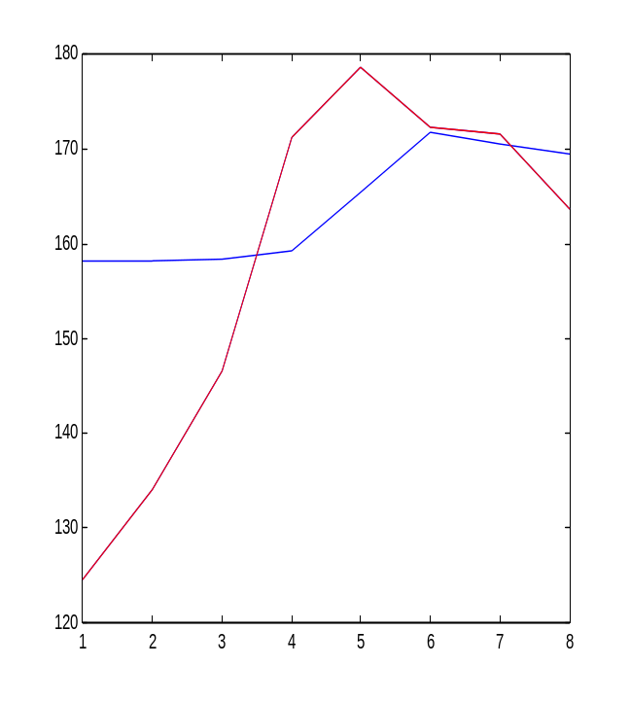

Learning Vector Quantization (LVQ)
LVQ networks are used to solve classification problems. Now we use iris data to implement this technique. Iris data is very popular in data mining or statistics study where the dimension is 150 by 5. The row is the number of observations and the last column of the data indicates the class. There are 3 classes in the data.
The following set of commands is to specify our training and testing data:
» load iris.txt
» x=sortrows(iris,2);
» P=x(21:150,1:4);
» T=x(21:150,5);
» a=x(1:20,1:4);
» s=x(1:20,5);

An LVQ network can be created with the function newlvq.

Syntax
net = newlvq(PR,S1,PC,LR,LF)

NET = NEWLVQ(PR,S1,PC,LR,LF) takes these inputs,
PR - Rx2 matrix of min and max values for R input elements.
S1 - Number of hidden neurons.
PC - S2 element vector of typical class percentages.
The dimension depends on the number of classes in our data
set. Each element indicates the percentage of each class.
The percentages must sum to 1.
LR - Learning rate, default = 0.01.
LF - Learning function, default = 'learnlv2'.The

The following code is to implement LVQ network.

P=input('input matrix training: ');
T=input('input matrix target training: ');
a=input('input matrix testing: ');
s=input('input matrix target testing: ');
Tc = ind2vec(T');
net=newlvq(minmax(P'),6,[49/130 36/130 45/130]);
net.trainParam.epochs=700;
net=train (net,P',Tc);
y=sim(net,a');
lb=vec2ind(y);
[s lb’]
ans

2 2
2 2
2 2
3 1
1 1
2 2
2 2
2 2
2 2
2 2
2 2
2 2
2 1
2 2
2 2
3 2
3 1
3 1
3 1
2 2

% is a sign not to execute any words after that, the phrase is just comment. We can ignore this comment

